**Postman Test Automation Using Newman**

* **Newman** is an open-source command-line tool (built on Node.js) for running and testing Postman Collections outside the Postman GUI
* It supports the same pre-request and test scripts as Postman, making it ideal for automation and CI pipelines.

**Overview**

This guide provides step-by-step instructions for:

* Writing Pre-request and Post-response scripts in Postman.
* Running the API test collections using Newman, the CLI companion tool for Postman.
* Generating HTML test reports.

**Prerequisites**

* Postman installed: <https://www.postman.com/downloads/>
* Node.js installed: <https://nodejs.org/>
* Newman installed via npm:

npm install -g newman

**1. Creating Pre-request and Test Scripts in Postman**

**1.1 Create a Collection and Add Request**

* Open Postman.
* Click "Collections" → "New Collection" → Name it.
* Add a request (e.g., a GET or POST request) to your collection.

**1.2 Pre-request Script**

A Pre-request Script is JavaScript code that executes *before* an API request is sent. It enables you to set up variables, generate dynamic data, and configure request parameters such as headers or authentication tokens.

**Steps:**

1. Go to your request → Click on the "Pre-request Script" tab.
2. Add your script.

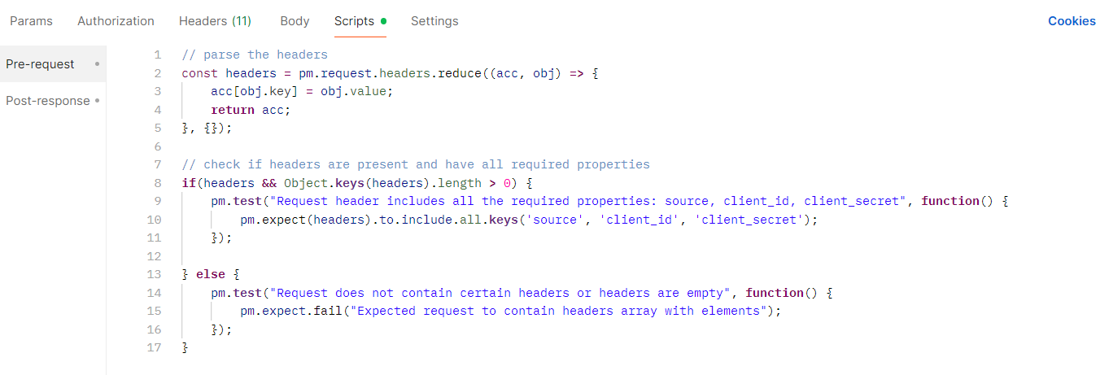

**1.3 Post-response Script**

Also known as a Test Script, this JavaScript runs *after* a response is received. It’s used to verify outcomes, assert conditions on status codes, headers, response time, and body content.

**Steps:**

1. Go to your request → Click on the "Post-response Script" tab.
2. Add your script.

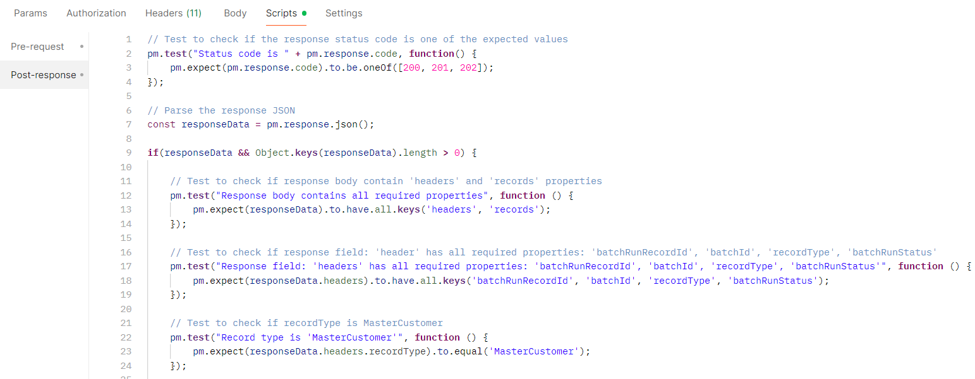

**2. Exporting Collection**

Before using Newman, export your Postman collection:

* Go to Collections → Hover over your collection → Click "..." → "Export"
* Select Collection v2.1 (recommended) → Save as collection.json

Also export environment (if needed):

* Go to Environments → Select the environment → Click "..." → "Export"

**3. Running Tests with Newman**

**3.1 Basic Run :**

newman run collection.json

**3.2 With Environment :**

newman run collection.json -e environment.json

**3.3 Generate HTML Report :**

npm install -g newman-reporter-html

**3.4 Run with HTML report :**

newman run collection.json -e environment.json -r html

